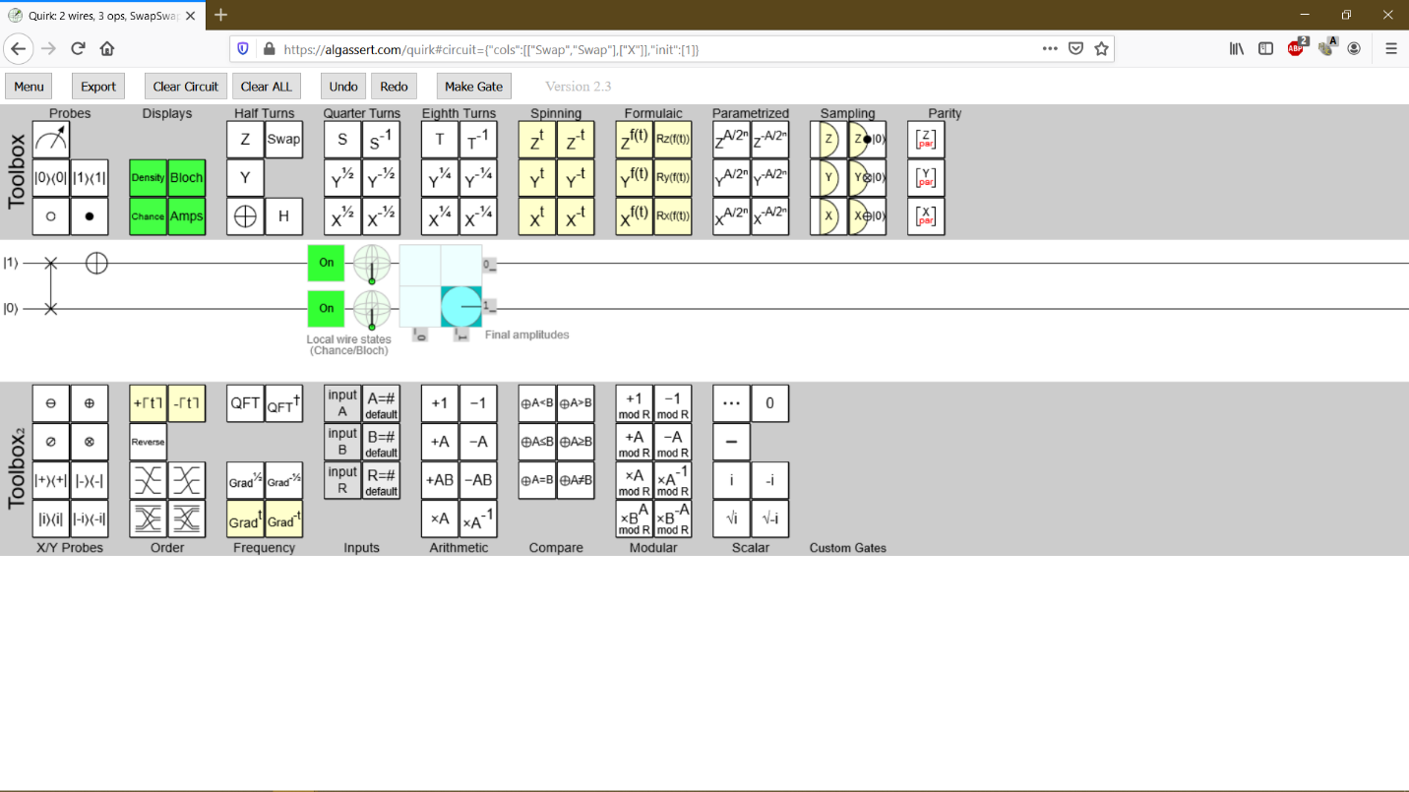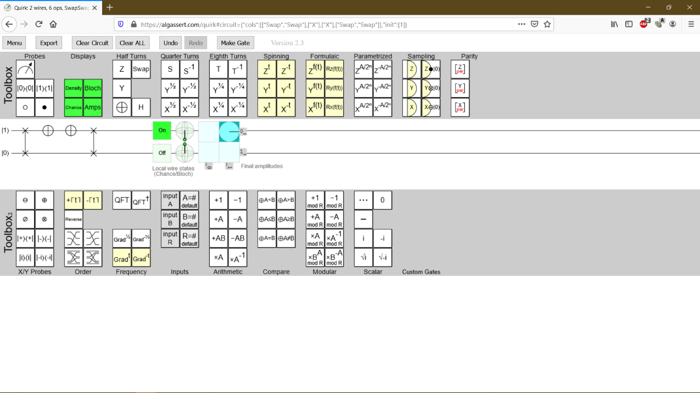

Explanation:

1. 1st picture, you SWAP the two lines and NOT the first line
2. 2nd picture, continuing the 1st picture, you then NOT the first line back, and then SWAP back the two lines.

Essentially you reversed the computation.